1. ***Draw the DFD for library management system***

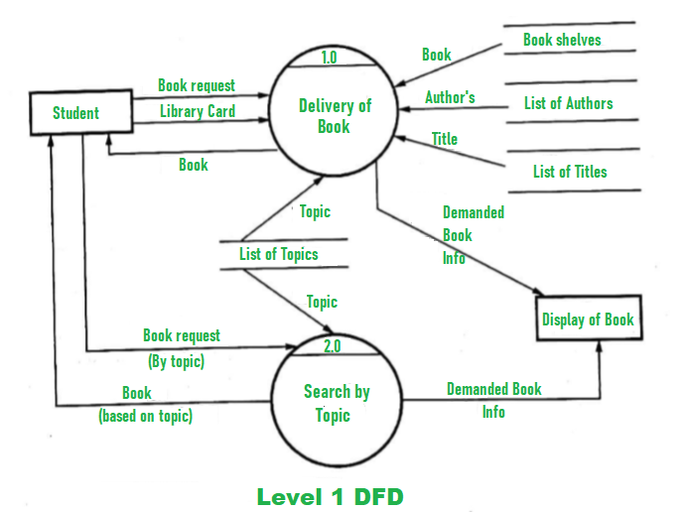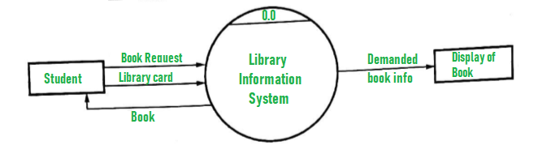

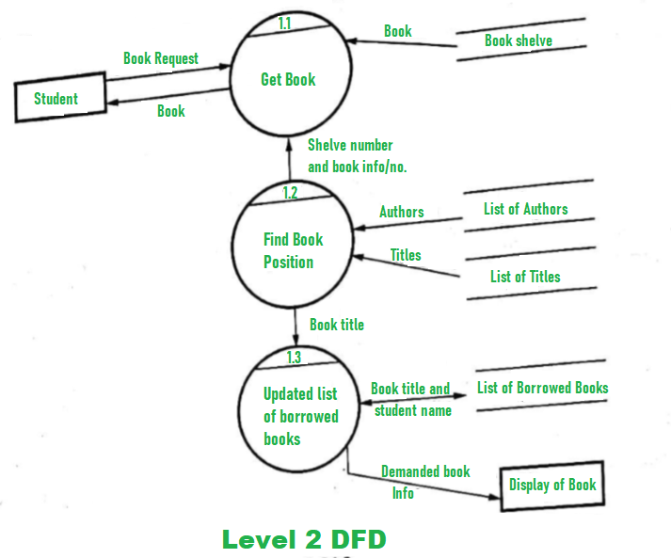

1. ***class diagram for railway reservation system***

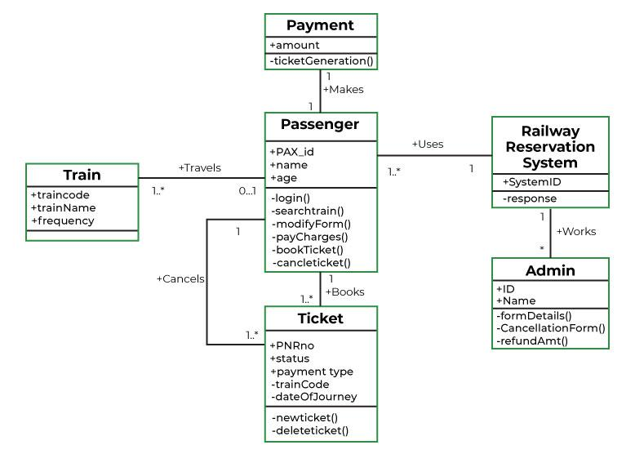

1. 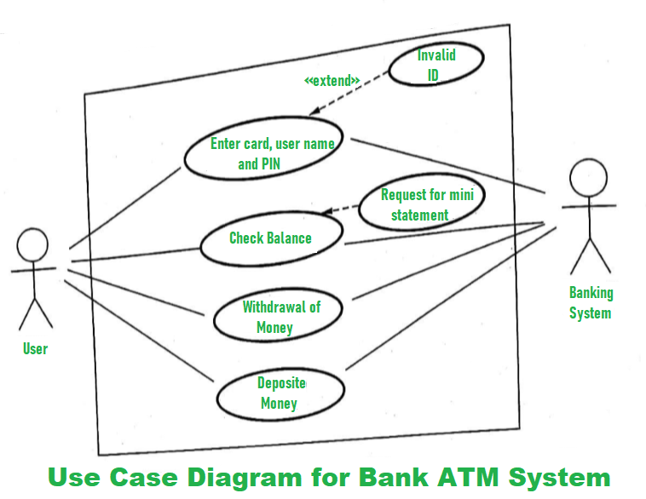***use case diagram for ATM***
2. ***sequence diagram for phone call***

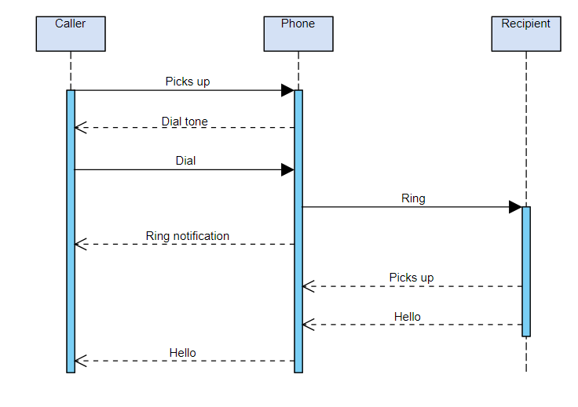

1. ***use case diagram for hotel management system***

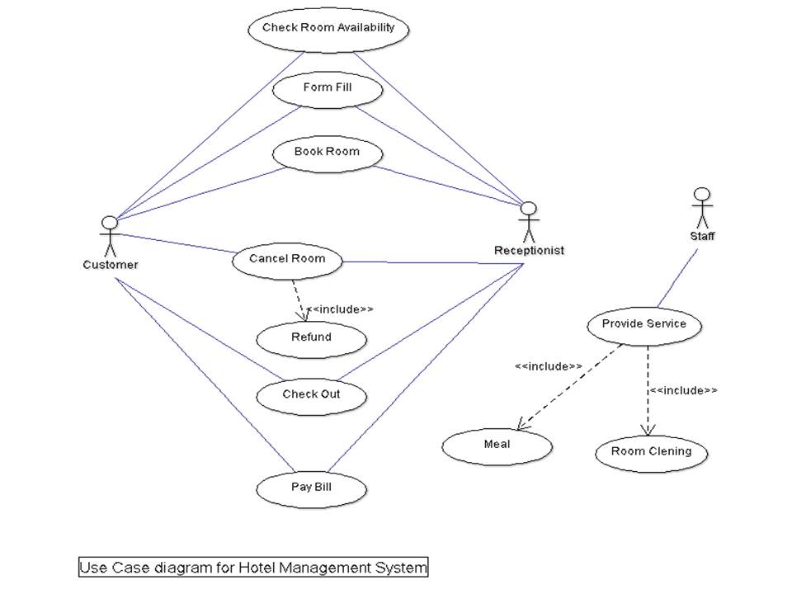

1. ***class diagram for library management system***

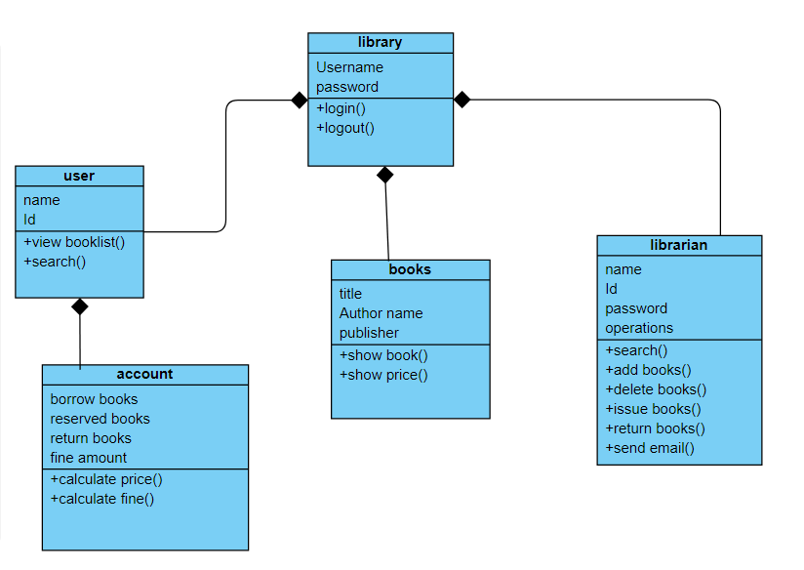

1. ***DFD for hospital management system***

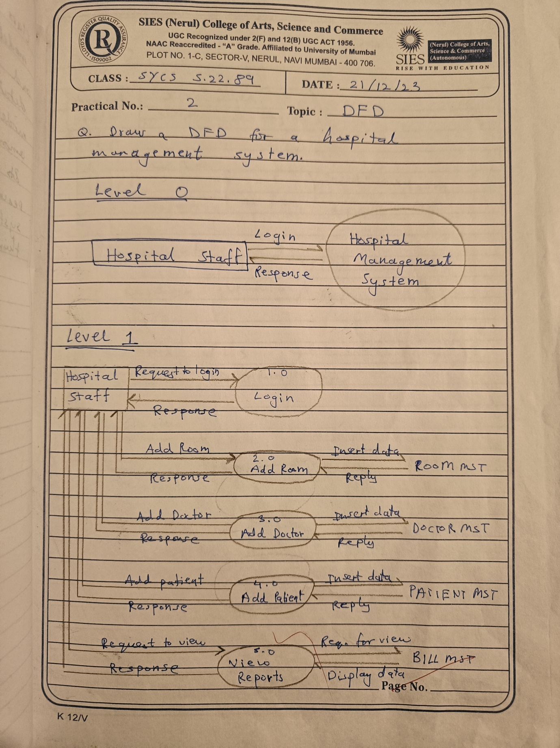

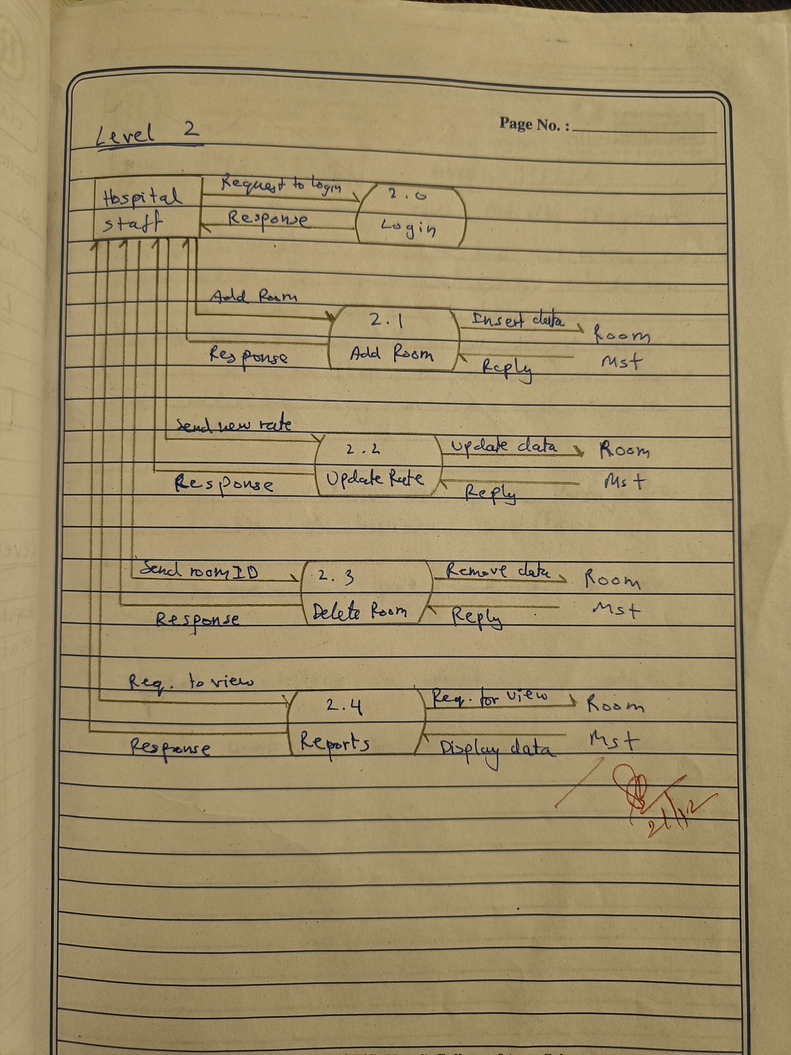

1. ***Activity diagram for railway reservation system***

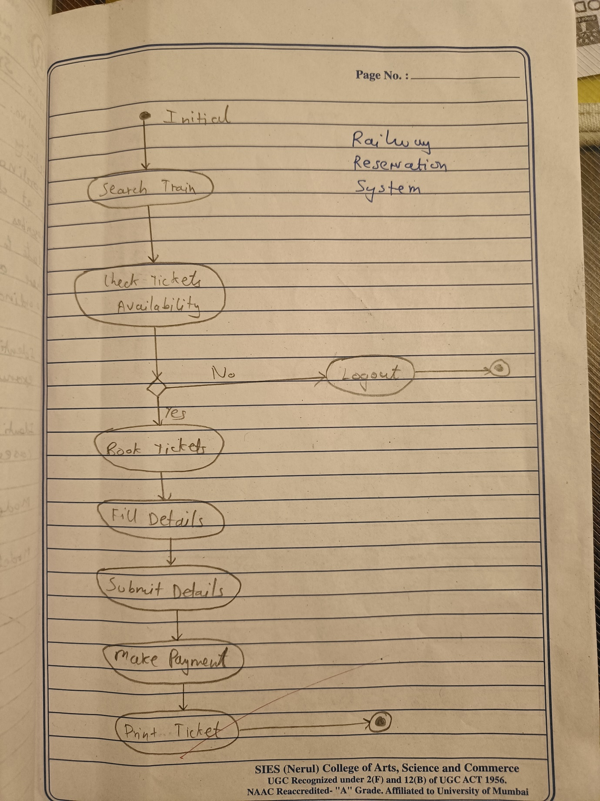

1. ***DFD for fast food billing system***

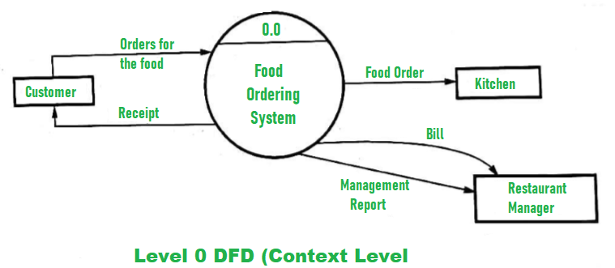

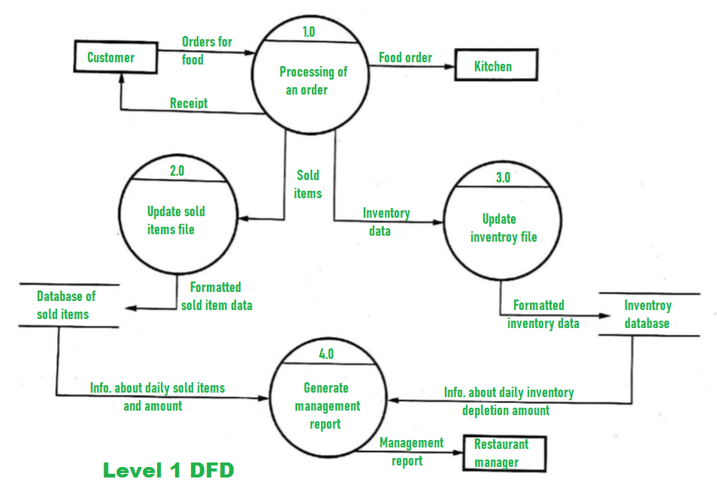

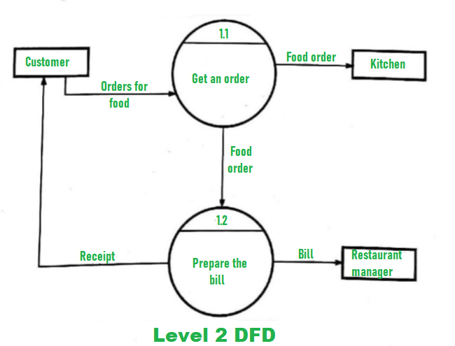

1. ***SRS for library management system***

1. **Introduction:**

- Brief overview of the Library Management System.

- Purpose of the document.

- Scope of the system, including intended users and stakeholders.

2. **General Description:**

- Description of the overall functionality and objectives of the system.

- Overview of the library system's components, including user interfaces, databases, and external interfaces.

3. **Specific Requirements:**

- **Functional Requirements:**

- User Registration: Ability for users to create accounts with unique identifiers.

- Book Management: Functions for adding, updating, and deleting books from the library inventory.

- User Management: Features for managing user accounts, including editing profiles and password reset options.

- Borrowing and Returning: Processes for checking out and returning books, including due date management and fine calculation.

- Search and Browse: Functions for users to search and browse the library catalog by title, author, genre, etc.

- Reservation and Hold: Capability for users to reserve or place holds on books that are currently unavailable.

- Reporting: Generation of reports on book availability, user activity, overdue books, etc.

- **Non-Functional Requirements:**

- Performance: Response time for user actions such as searches and checkouts.

- Security: Measures to protect user data, prevent unauthorized access, and secure transactions.

- Scalability: Ability of the system to handle an increasing number of users and books.

- Usability: Intuitive user interfaces and clear instructions for users of varying technical expertise.

- Reliability: System uptime and reliability in handling concurrent user requests.

- Compatibility: Compatibility with different web browsers and operating systems.

4. **External Interface Requirements:**

- User Interfaces: Description of the interfaces for users, administrators, and librarians.

- Hardware Interfaces: Requirements for any hardware components such as barcode scanners or RFID readers.

- Software Interfaces: Integration requirements with external systems such as payment gateways or authentication services.

5. **System Features:**

- Detailed description of each feature of the Library Management System, including use cases and user stories.

6. **Other Non-Functional Requirements:**

- Legal and Regulatory Requirements: Compliance with data protection laws, copyright regulations, etc.

- Documentation Requirements: Specifications for user manuals, technical documentation, and help guides.

- Training and Support: Requirements for user training sessions and ongoing technical support for administrators.

7. **Appendices:**

- Glossary: Definitions of terms used throughout the document.

- References: Citations for any external sources or standards referenced in the SRS.

1. ***use case diagram for library management system***

